WHO ARE THESE GUYS???
A fun activity to do with your folks- Instead of a “Teach a Parent”
Can you guess which element the clues match??
Directions: Use your knowledge of the Periodic Table to match the elements listed below with each descriptive statement. Write the element next to the clue
1. What Mr. President’s speeches do. ( example: BORON) ☺
2. What you do when a guy bugs you to get engaged.
3. The Lone Ranger’s favorite pet.
4. Another name for a policeman.
5. Coke and Pepsi, but not water.
6. What doctors do for an ill person.
7. An evening warrior raiding Rome.
8. What body builders want to do to their muscles.
9. The unsinkable ship that did.
10. What a baby says when their bottle is empty.
11. What the police do to illegal card games.
12. A place to stash your automobiles.
13. What the police do to a robber.
14. A nice red flower.
15. This person did work in Arabia.
16. The only good thing to do to a dead skunk.
17. The place to ride a bucking bronco.
18. Someone who has no stomach.
19. What happens to your boat if it has a hole in it.
20. An old car brand.
21. A funny convict.
22. A broken leg takes time to do this.
23. What to do when a lush comes to visit.
24. What to do when your date stands you up at a restaurant.
26. Why women wear perfume.
Parent Signature:
27. You buy milk in this volume.
28. Where Superman is from.
29. A wooden one of these isn’t worth very much.
30. What to do to get a stray cattle.
31. Donny & Marie.
32. Goofy’s friend.
33. You ride horses in this game.
34. Men or women pay this when they divorce their spouses.
Your choices:
Antimony ...Fermium.... Mercury... Samarium…Argon ...Gallium ....Nickel.... Silicon… Barium ...Germanium.... Nitrogen ....Silver…Boron ....Helium... Nobelium.... Sodium…Carbon ....Hydrogen.... Osmium.... Tellurium
Cesium.... Iodine.... Plutonium.... Titanium…Copper.... Iron.... Polonium....
Zinc..Curium.... Krypton.... Radium …Europium ....Lawrencium.... Rhodium
-16-
My Chapter 13 Little Book on:
The
Periodic Table

Draw and label an example of an element’s Periodic Table Square
Use pg 328 as a guide & as an example

Name: ____________________________ Pd____ Number:____
Parent Signature: ___________________________________
Definitions: From the Book / or YOUR definition
Word:  Pg found | Sect 1: Arranging the Elements Pg 324-333
Periodic | _______________________________________________________  _______________________________________________________  _______________________________________________________  _______________________________________________________
Periodic  Law | _______________________________________________________  _______________________________________________________  _______________________________________________________  _______________________________________________________
Period | _______________________________________________________  _______________________________________________________  _______________________________________________________  _______________________________________________________
Group | _______________________________________________________  _______________________________________________________  _______________________________________________________  _______________________________________________________
Sect 2: Grouping the elements on pgs 334-341
Alkali  metals | _______________________________________________________  _______________________________________________________  _______________________________________________________  _______________________________________________________
Alkaline-earth  metals | _______________________________________________________  _______________________________________________________  _______________________________________________________  _______________________________________________________
halogens | _______________________________________________________  _______________________________________________________  _______________________________________________________  _______________________________________________________
Noble gases | _______________________________________________________  _______________________________________________________  _______________________________________________________  _______________________________________________________
Pg-2
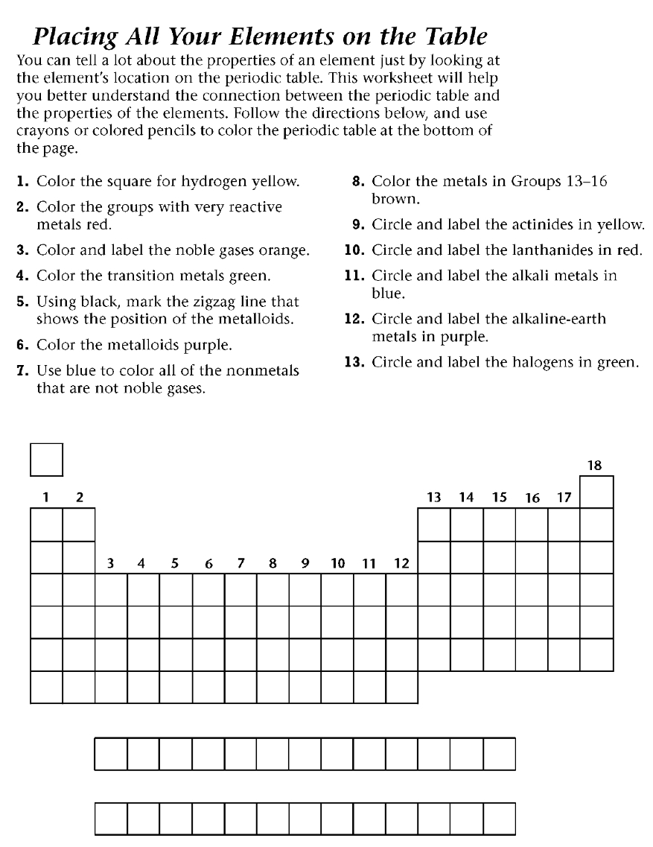

pg 15
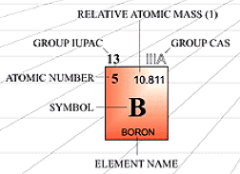
Atomic Structure Chart
An atom is made up of protons & neutrons (found in the nucleus) and electrons (in the surrounding electron cloud). The atomic number is equal to the number of protons. The mass number is equal to the number of protons PLUS neutrons. In a neutral atom, the number of protons equals the number of electrons. Complete the chart below using your periodic table!

Element  Symbol | Element  Name | Atomic  Number | Atomic  Mass | Protons | Neutrons | Electrons
H
 | Carbon
Li
 | Chlorine
Ne
 | Silver
Sm
 | Chlorine
-14-
Bite Size Lab!!!

Go to:
http://www.bbc.co.uk/schools/ks3bitesize/science/chemical_material_
behaviour/atoms_elements/activity.shtml

Atoms and elements - Test Bite

1. Which of these is the smallest particle?
a) an atom b) a molecule c) a speck of dust

2. Which of these is the correct symbol for magnesium?
a) MG b) mg c) Mg

3. Which statement about elements is correct?
a) most elements are metals
b) most elements are non-metals
c) there are about the same number of metals and non-metals

4. Where are the metals found in the periodic table?
a) on the left b) on the right c) scattered all over

5. Which of the following is not a general property of metals?
a) shiny b) good conductor of heat c) poor conductor of electricity

6. Which of the following is not a general property of non-metals?
a) brittle b) strong c) poor conductor of heat

7. An element sinks in water and makes ringing sound when hit.
It is most likely to be:
a) a metal b) a non-metal c) an alloy

Additional Notes: ___________________________________________
__________________________________________________________
__________________________________________________________
__________________________________________________________
__________________________________________________________
__________________________________________________________
__________________________________________________________
__________________________________________________________
-3-
Section 1: Arranging the Elements (p 326 – 333)
1. Why do you think scientists might have been frustrated by the
organization of the elements before 1869? _________________________________________________________
_________________________________________________________
2. Mendeleev spent a lot of train rides organizing the elements
according to their properties. He organized the elements according
to their ____________________. (figure 1)
3. He noticed after arranging the elements that similar _______________
and ____________ properties could be observed in every ____________
element.
4. Mendeleev was even able to predict the properties of elements that
no one knew about. How was this possible? ____________________________________________________________
____________________________________________________________
5. A few elements in Mendeleev's table seemed to be mysteriously out of place according to their properties. How did Moseley solve the mystery?
____________________________________________________________
____________________________________________________________
____________________________________________________________
6. The ________________________ states that the chemical &
physical properties of elements are periodic functions of their ______________ numbers.
7. Which information is NOT included in each square of the periodic
table in your text?
a. Atomic number b. chemical symbol c. melting point d. atomic mass
8. Rows of elements are called: ______________ and columns of
elements are called:____________What page did you find this on?_____
9. Elements are classified as metals, nonmetals or metalloids, according to their ______________. The number of _______________ in the outer _____________ level of an atom also helps determine which
category an element belongs in.
10. There is a zigzag line on the periodic table. How can it help you? _______________________________________________________ _______________________________________________________
-4-
Group # | Name | Valence Electrons  electrons in the outer level | Reactivity | Important Properties & Facts
15
16
17
18
Hydrogen
Additional Notes: __________________________________________
_________________________________________________________
_________________________________________________________
__________________________________________________________________________________________________________________
-13-
Section 2: Chart: Grouping the Elements (p 334-341)
Group # | Name | Valence Electrons  (electrons in the outer level) | Reactivity | Important Properties & Facts
1 | Alkali Metals | 1 | Very Reactive | Soft enough to be cut with a knife  Low densities  React violently with water (usually stored in oil)
2
3-12
13
14
-12-
11. Some elements are names after scientists like Einstein, and places
like California. True/False

12. The chemical symbol Pb comes from the __________ word
plumbum, which means:________

13. What happens as you move from left to right though each period
on the periodic table?
a. Elements change from having properties of nonmetals
to having metal properties
b. Elements change from having properties of metalloids
to having metal properties
c. Elements change from liquids to gases
d. None of these: write what does happen:
14. Silicon is a: ____________ (metal, nonmetal or metalloid)
Name 2 liquid elements: ______________________________________
Name 4 gas elements: ________________________________________
Use the pictures on pgs 330-331 to help you match the category in
Column B with the description in Column A, writing the corresponding
letter in the space provided. Categories may be used more than once.
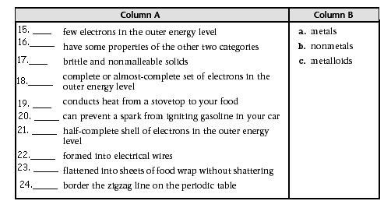
25. Rows of elements on the PT are called: _____________________
26. Columns of elements on the PT are called:___________________
-5-

Chp 13.2 Tour Through the Chapter :Grouping the Elements (p 334)

1. Why do elements in a family or group have similar properties?
a. The have the same atomic mass
b. They have the same number of protons in their nuclei
c. They have the same number of electrons in their outer energy level
d. They have the same number of total electrons

Groups 1 & 2: Very reactive metals (p 334)
2. The elements in groups 1 & 2 are very reactive. Explain.
_______________________________________________
_______________________________________________
_______________________________________________
_______________________________________________

3. Which of the following is NOT true of alkali metals?
a. They can be cut with a knife b. They are usually stored in water
c. They are the most reactive of all the metals
d. They can easily give away their outer electrons

4. How are the following alkali metal compounds useful?
a. sodium chloride: ______________________________________
b. sodium hydroxide: ____________________________________
c. potassium bromide: ____________________________________

5. Alkaline-earth metals have ____ electrons in their outer energy level.
They are less ___________and more ____________ than alkali metals.

6. Calcium is the alkaline-earth metal that makes up a compound that is healthy for your teeth. True or false? (circle one)

Groups 3-12: Transition Metals (p 336)
7. Besides collectively being called transition metals, Groups 3-12 also
have individual names. True or false? (circle one)

8. Which of the following characteristics describes transition metals?
a. good conductors b. more reactive than alkali and alkaline-earth metals
c. 1 or 2 electrons in the outer energy level
d. denser than elements in Group 1 & 2

-6-
Teach a parent: Today’s concept is:
Explain the different Families / Groups on the Periodic Table
This is really important! Open your Periodic Table and explain the different parts of it. What are metals, nonmetals & metalloids, and some information about each of the families.
Help your parent become an expert !
A. Simply explain the concept. No written work is necessary.
B. Explain the concept and use some notebook paper to show real-life examples you created
while teaching.
C. Write out the thought process you will use to explain the concept. You may do this in steps or
a one-chunk paragraph form.
D. Show real-life examples you used along the way to effectively explain the process.
Parent Response
1. _____ I'm not sure my child really understands, therefore, I don't either. Please work with
him/her and let's try again.
2. _____ The concept was explained thoroughly with effective examples he/she created.
"By golly, I think they've got it!"
3. _____ WOW! My child did an exceptional job! It was logically explained, therefore I caught on
immediately and feel confident about teaching it to others. The self-created examples were a
perfect fit. My child even asked me a question at the end to make sure I understood.
I believe my child could effectively teach this concept to others.

Parent Signature:_________________________ Date: _______
Mom or Dad Comments: Please explain how your student taught you this
concept and * what you learned in 3-5 sentences! *
_________________________________________________________________
_________________________________________________________________
_________________________________________________________________
_________________________________________________________________
_________________________________________________________________
_________________________________________________________________
_________________________________________________________________
Space for any additional notes from this section:
_________________________________________________________________
_________________________________________________________________
_________________________________________________________________
_________________________________________________________________
_________________________________________________________________
_________________________________________________________________
_________________________________________________________________
_________________________________________________________________
________________________________________________________________
-11-

Groups 17 and 18: Nonmetals Only (pg 340)
22. Which of the following statements is true?
a. Group 17 elements are the most reactive metals
b. Group 18 elements are the least reactive metals
c. Group 18 elements are the least reactive nonmetals
23. What does Fig 12 show about the physical properties of halogens?
_______________________________________________
_____________________________________________
24. Halogens are very reactive because of the number of electrons in
their outer energy level. True/false
25.What important use do the halogens iodine & chlorine have in common?
________________________________________________________
________________________________________________________
26. Which of the following statements are true of noble gasses.
(circle all that apply)
a. they are colorless & odorless at room temperature
b.They normally react with other elements
c. They are metals
d. They have a complete set of electrons in their outer energy level
27. Take a moment to look at Fig 13.(pg341) Why do neon signs
contain other nobel gases besides neon? Give an example. _____________________________________________

Hydrogen Stands Apart (pg 341)
Mark each of the following statements True or false
28. _______ Hydrogen is useful as rocket fuel
29. _______ Hydrogen has 2 electrons in its outer energy level
30. _______ Hydrogen is the most abundant element in the universe
31. _______ The physical properties of hydrogen are close to those
of nonmetals than to those of metals.

additional notes
__________________________________________________________
_________________________________________________________________
_________________________________________________________________
_________________________________________________________________
_________________________________________________________________
_________________________________________________________________

-10-
Groups 1 & 2.
9. Mercury is different from other transition metals in Fig 7. how?
___________________________________________
___________________________________________
10. Two rows of ________________ are placed at the bottom of the periodic table to save space. Elements in the ___________row are called lanthanides and are shiny, ___________ metals.

11. Which lanthanide forms a compound that makes you see red on a computer screen like the one in Fig 8?____________________________

12. All actinides are radioactive. True or false? (circle one)
13. Which actinide is used in some smoke detectors? ________________
Groups 13-16: Groups that Include metalloids (p 338)
14. Look at Fig 9. The most common element of Group 13, aluminum,
was once considered so valuable that Napoleon III used it as dinnerware.
True or false? (circle one)
15. What do diamonds, crayons and proteins have in common?
________________________
16.Phosphorous, which makes up about 80% of the air you breathe,
is used in fertilizers. True / false?
17. All substances need the element oxygen to : ____________
Complete the following section after you finish reading about
Groups 13-16. Each of the following statements are false.
Change the underlined word to make the statement true.
Write the new word in the space provided.
18. Oxygen group elements contain 5 electrons in the outer energy level.
______________
19. The carbon group contains no nonmetals. ______________________
20. The Nitrogen and boron groups have the same number of electrons in the outer energy level which is: __________
21. Not all carbon group and oxygen group elements are solid at room temperature. ___________

-7-


